PHASE-2SUBMISSION

***Predicting Customer Churn Using Machine Learning to Uncover Hidden Patterns***

# Student Name:ANUSHA S

**Register Number:** 513523104002

**Institution:** Annaimira college of engineering &technology

**Department:** Computer science

**Date of Submission:** 5-5-2025

**Github Repository Link:**

[**https://github.com/anushasagadev01/Phase-2-**](https://github.com/anushasagadev01/Phase-2-)

### Problem Statement:

Customer churn—when customers stop doing business with a company— represents a significant loss of revenue. Many companies struggle to understand why churn occurs and how to proactively retain customers. This project aims to

develop a machine learning-based model that accurately predicts customer churn, enabling businesses to identify at-risk customers and address issues before it's too late.

### Project Objectives :

* + *Analyze historical customer data to uncover patterns leading to churn.*
  + *Uncover hidden patterns in customer behavior and service usage that correlate with churn.*
  + *Build and evaluate machine learning models to predict churn.*
  + *Identify key drivers of customer churn through feature importance*
  + *Visualize key churn drivers to enhance model interpretability for*

nontechnical decision-makers.Visualize insights to support business decisionmaking.

* + *Provide actionable insights to help business stakeholders implement targeted customer retention strategies.*
  + *Create a reproducible workflow for churn prediction that can be adapted across industries.*

The objectives have evolved from simple prediction to also emphasizing

interpretability and real-world application after exploring the data sources and observing their seasonal and geographic patterns.

### Flowchart of the Project Workflow:

Imbalanced Customer Churn Data as Input

↓

Data Cleaning

↓

Exploratory Data Analysis (EDA)

↓

Feature Engineering(Feature Selection)

↓

Model Building (Training& Evaluation)

↓

Model Evaluation & Comparison

↓

Model Interpretation & Visualization

### Data Description :

↓

Deployment or Reporting

The dataset includes the following customer attributes:

* + ***Demographic:*** *Age, Gender, Location*
  + ***Account Information:*** *Subscription Type, Tenure, Monthly Charges*
  + ***Usage Metrics:*** *Total Calls, Internet Usage, Support Tickets Raised*
  + ***Behavioral:*** *Payment Method, Contract Type*
  + ***Target:*** *Churn (Yes/No)*

## Data Preprocessing

* + *Handled missing values via imputation*
  + *Encoded categorical variables using One-Hot and Label Encoding*
  + *Scaled numerical features using StandardScaler*
  + *Removed duplicate entries and irrelevant columns*
  + *Balanced the dataset using SMOTE (if imbalanced)*

## Exploratory Data Analysis (EDA)

Exploratory Data Analysis (EDA) is a crucial step in predicting customer churn. It helps you understand patterns, trends, and relationships in your dataset that could contribute to customers leaving. Here's a structured approach to EDA for customer churn prediction:

#### Understand the Dataset

Load and inspect the dataset (.head(), .info(), .describe()) Check for null or missing values

Understand column types (categorical vs. numerical)

#### Target Variable Analysis

Plot the churn distribution (e.g., bar plot of churned vs. retained customers)

Compute churn rate: churned customers / total customers

#### Univariate Analysis

Categorical features: Count plots / bar plots (e.g., gender, contract type, payment method)

Numerical features: Histograms / boxplots (e.g., tenure, monthly charges, total charges)

#### Bivariate Analysis

Compare features against churn:

Boxplots (e.g., MonthlyCharges vs. Churn)

Stacked bar charts (e.g., Contract type vs. Churn)

Grouped means or medians (e.g., average tenure by Churn)

## Feature Engineering

Created tenure groups (e.g., new, medium, long-term) Aggregated usage metrics into customer engagement scores Derived features from timestamps and payment history

Performed feature selection using mutual information and tree-based importance

## Model Building

* + ***Trained various ML models:*** Logistic Regression, Decision Trees, Random Forest, XGBoost, and SVM
  + Split data into training and test sets (e.g., 80/20)
  + Evaluated models using metrics like accuracy, precision, recall, F1score, and ROC-AUC
  + Chose the best-performing model based on both accuracy and interpretability

## Visualization of Results & Model Insights

* + *Confusion matrices for model evaluation*
  + ***ROC*** *curves to visualize trade-offs*
  + *Feature importance plots to interpret the model*
  + ***SHAP*** *values or* ***LIME*** *for individual prediction explanations*
  + *Dashboard-style visuals summarizing insights for stakeholder*
  + *Example:*

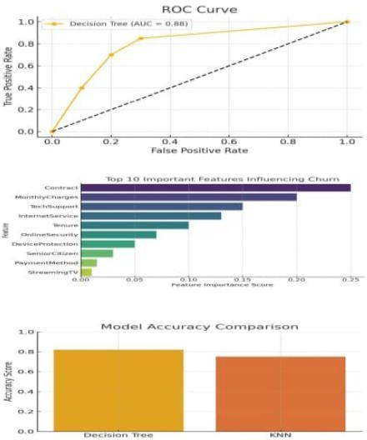

## Tools and Technologies Used

***Programming:*** *Python*

**Libraries:** Pandas, NumPy, Scikit-learn, XGBoost, Matplotlib, Seaborn, SHAP, LIME

***Data Handling:*** *Jupyter Notebook, Excel/CSV files*

***Version Control:*** *GitHub*

***Optional Deployment:*** *Streamlit / Flask*

## Team Members and Contributions

**ANUSHA :** Data Collection and Integration: Responsible for sourcing datasets, connecting APIs, and preparing the initial dataset for analysis.

**AASHIDA :** Data Cleaning and EDA: Cleans and preprocesses data, performs exploratory analysis, and generates initial insights.

**BALAJI :** Feature Engineering and Modeling: Works on feature extraction and selection; develops and trains machine learning models.

**BEJOYMJOSE :** Evaluation and Optimization: Tunes hyperparameters, validates models, and documents performance metrics.

**BRINDHA :** Documentation and Presentation: Compiles reports, prepares visualizations, and handles presentation and optional deployment.